Socioemotional Wealth in Family Firms
A Literature Review

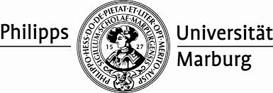

Chair of Strategic and International Management
Prof. Dr. Torsten Wulf

Bachelor Thesis/Master Thesis
Supervisor:
Prof. Dr. Torsten Wulf
Christian Hoffmann

Submitted by:
Prename Name
Matriculation Number
Adress
Email

Submission Date Marburg, February 5th 2014

