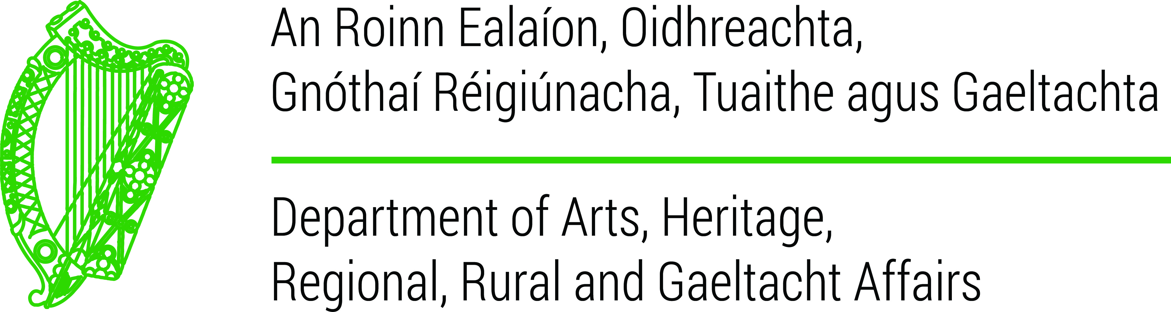

Grant Agreement
between the
Department of Arts, Heritage, Regional, Rural and
Gaeltacht Affairs
and
University of Marburg
2016/17 – 2018/19

- Introduction
The Department of Arts Heritage, Regional, Rural and Gaeltacht Affairs provides grants to international Universities to promote the teaching of Irish in foreign universities. The objectives of the fund are to promote and foster goodwill for the Irish language outside Ireland and to provide a platform from which the Irish language can be accessed and showcased as an international language.

This Grant Agreement (the Agreement) is a performance contract in which an agreed level of service is formalised between the Department of Arts, Heritage, Regional, Rural and Gaeltacht Affairs (the Department) and University of Marburg (the University). This is to ensure that resources are used in an effective and cost effective manner to deliver quality services to the clients of both bodies. The Agreement will set out the University’s targets for the period 2016/17 to 2018/19 and define the output indicators on which performance should be measured.

The Agreement will support the high level goal of the Department to support the teaching of Irish in international institutions.

- Objectives of the Agreement
The key objectives of this agreement are:
- to clarify the University’s role and objectives;
- to clarify the expectations of the Department in relation to the University;
- to define the inputs and outputs of the University’s activities;
- to measure performance of these functions through monitoring of agreed outputs.

- Commitments
- Both parties commit to proactive and timely communications, cooperation and information sharing on service delivery.
- Both parties support the effective achievement of agreed targets as well as the promotion of partnership, responsiveness and mutual cooperation in their ongoing interactions.
- Both parties support prompt and timely responses to correspondence, information requests and related matters.
- Both parties commit to keep each other fully apprised and updated on all key issues.
- The University agrees to maintain statistical records relating to teaching programmes funded. These records shall be provided to the Department on request and shall include, but shall not be limited to, the funding provided for each element of the programme, the number of students enrolled and successful in exams on each course and the number of students attending Irish language courses in Ireland .
- The University agrees to maintain, for a period of five years, financial records relating to teaching programmes funded. These records shall either be provided to the Department on request or, alternatively, the University will facilitate the Department’s representatives in inspecting these records on site at the University.

- Financial Inputs

 | 2016/17 | 2017/18 | 2018/19
Department of Arts, Heritage Regional, Rural and Gaeltacht Affairs | €5,200 | €5,200 | €5,200

Payment of each draw-down is dependent on compliance by the University with Irish public financial procedures. Funding for the years 2017/18 and 2018/19 is contingent on sufficient monies being available to the Department in those years.

- Other Inputs
Both parties agree to provide sufficient administrative staff in order to ensure the efficient provision of the services detailed in this Agreement.

- Service Levels and Performance Measurement

Key outputs
The University offers teaching of two modules Modern Irish courses as part of the BA course within the Celtic Studies programme as follows:-
- Introduction to Modern Irish
- Advanced Modern Irish
- Irish language course in Ireland

Funding is also being provided for a scholarship for one student to attend an intensive Irish summer course in the Gaeltacht region of Ireland.

- Potential Risk Factors
- A low level risk surrounding the availability of sufficient budgetary resources in the Department of Arts, Heritage, Regional, Rural and Gaeltacht Affairs.
- A low level risk that the University will fail to fulfil the conditions attached to its financial allocation.

- Financial Allocation
The Department will formally write to the University setting out:
- Its annual funding allocation.
- The manner in which payment will be made, i.e. instalments.

The University will provide:
- A letter with the University’s letterhead seeking payment of each funding instalment.
- A valid Tax Clearance Cert from the Irish Revenue Commissioners.
- Supplier Bank Account details.
- Academic and financial reports in respect of each academic year for which funding is being requested.

Payment of each draw-down is dependent on compliance with the procedures above and
with any further requirements outlined in this document.

- Flexibility and Amendment of Targets
Where amendments become necessary, the University and the Department will mutually engage to agree amended output targets.

The Department will require a progress report on all key deliverables on an annual basis. The time-lines for these progress reports will be decided between the Department and the University. This Agreement will be published both on the Department's and on the University’s websites.

_______________________________________
On behalf of the Department of Arts, Heritage, Regional, Rural and Gaeltacht Affairs

Date: __________________

__________________________________
On behalf of the University of Marburg

Date: ______________________

