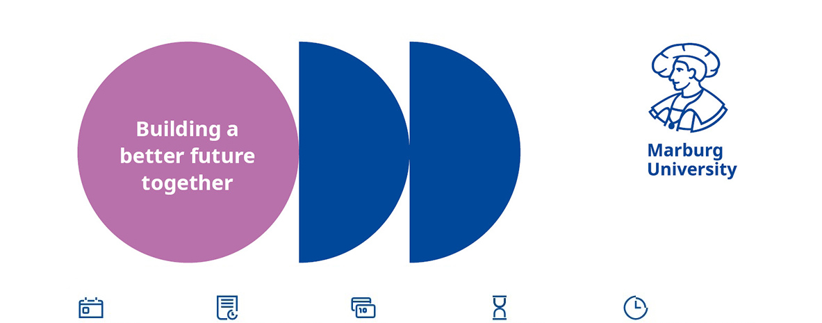

registration number:
[wird von Dez II B 1 vergeben]

Entry date:  [as soon as possible or date] | Application deadline:  [4 weeks] | Salary:  [W2 / W3 HBesG] | Duration:  [permanent] | Volume of employment:  [full-time]

The University of Marburg, founded in 1527, offers multiple award-winning teaching for around 22,000 students and tackles the important issues of our time with excellent research across a broad spectrum of science.

Text 1 (max. 600 signs; Explanations: one line are ca. 100 signs):
The Department of […], Institute of […], invites applications for a

Title (max.l 200 signs):
Professorship (W 2 / W 3) for [Denomination]

Text 2 (max. 1.000 signs):
to be filled at the earliest possible date/by [term of study].

Professorships with a W2 or W3 salary at the University of Marburg are full professorships with their own staff and equipment.

Tasks:
The position holder should represent the subject of […] in research and the entire spectrum of […] in teaching. The call is aimed at internationally recognized scientists whose research focuses on […].

Profile:
A completed university degree in [name], an outstanding doctorate and a special pedagogical aptitude are required. Furthermore, additional academic and practical achievements as well as experience in the successful acquisition of third-party funding are [W2 = expected] [W3 = necessary]. Two years after taking up the position, knowledge of German at C1 level is required. The employment requirements of Sections 67 and 68 of the Hessian Higher Education Act (HessHG) apply.

The University of Marburg attaches great importance to intensive supervision of students and doctoral candidates and expects from its lecturers a pronounced presence at the university.

We offer:
(maximal 6 Bullet Points, jeweils maximal 200 Zeichen):

- the chance to become part of a renowned and future-oriented university
- ticket for free use of public transport in the state Hesse, Germany
- family service (holiday care, dual career services)
Beispiele für Benefits finden Sie hier

contact for more information
name
 | +49 6421-28 XXXXX |  | E-Mail

finish (max. 700 signs):
We support women and strongly encourage them to apply. As a certified family-friendly university, we support our employees in balancing family and career. Applicants with a disability as discribed in the Social Security Code (Section 2(2) and (3) of Book IX of the Social Security Code (SGB IX)) will be preferred in case of equal qualifications.

Contact for E-Mail-applications:
Please apply by [at least 4 weeks after publication] [if applicable, reference to documents to be submitted and possibly using the application form https://uni-marburg.de/em4qz] using the application button below.



