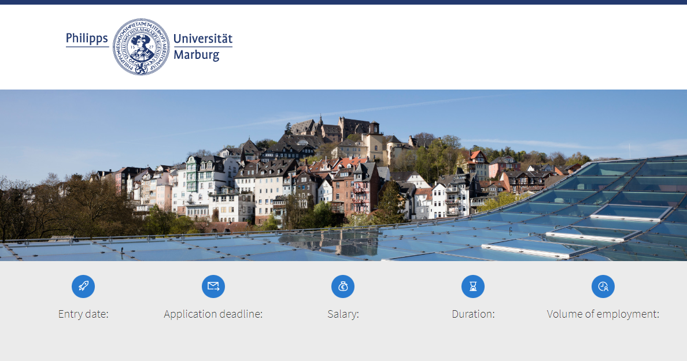
registration number: [wird von Dez II B 1 vergeben]

[as soon as possible or date] | [XX] | [E X TV-H] | [X years or until] | [fulltime/ part-time (X %)]
The Philipps University, founded in 1527, offers multiple award-winning teaching for around 22,000 students and tackles the important issues of our time with excellent research across a broad spectrum of science.

Text 1 (max. 600 signs; Explanations: one line are ca. 100 signs):
The Department of [], research group on “[]”, Prof. Dr. [] is currently accepting applications for a

Title (max.l 200 signs):
Research Assistant
(Doctoral Researcher/PhD )
(Postdoc )

Text 2 (max. 1.000 signs):
The position is offered for a period of [] years, if no former times of qualification must be considered. The starting date is as soon as possible or date. The position is fulltime/part-time (X % of regular working hours) with salary and benefits commensurate with a public service position in the state Hesse, Germany (TV-H E 13, X %).

Your tasks:
tasks (max. 6 Bullet Points, respectively max. 200 signs):

- include scientific services in research and teaching
- task 2
- task 3
- task 4
- task 5
- task 6

The position is limited to a time period deemed adequate for the completion of a doctoral degree. As part of the assigned duties, there will be ample opportunity to conduct the independent scientific research necessary for the completion of a doctorate. The limitation complies to § 2, 1 WissZeitVG.
The position is limited to the period which is adequate to the duration of the qualification period. The qualification goal is a habilitation or an equivalent qualification required for a professorship. Within the scope of the assigned duties it will offer the possibility of independent scientific research for further qualification. The limitation complies to § 2, 1 S 1 WissZeitVG .

The position will be filled by a temporary contract that is limited to the period which is necessary to gain further scientific expertise (such as the preparation for a subsequent qualification period). Within the entrusted tasks the opportunity for independent scientific work to obtain further personal qualification is given. The limitation of the contract complies to § 2 Abs. 1 WissZeitVG.

Your qualification:
qualifications (max. 6 Bullet Points, respectively max. 200 signs):

- MSc-degree or equivalent in []
- qualification 2
- qualification 3
- qualification 4
- qualification 5
- qualification 6

Disposition to own scientific qualification (e.g. a doctorate project in the area …) is expected.

We actively support the professional development of junior researchers by the offers of Marburg Research Academy (MARA), the International Office and the Higher Education Didactics Office.

contact for more informations
[form of adress, title, name, surname]
 | [+49 6421-28 XXXXX] |  | [E-Mail]

finish (max. 700 signs):
We support women and strongly encourage them to apply. In areas where women are underrepresented, female applicants will be preferred in case of equal qualifications. Applicants with children are welcome – Philipps-University is certified as a family-friendly university. Sharing a full-time position (§ 8 Abs. 2 S. 1 HGlG) as well as a reduction of working time is possible. Applicants with a disability as described in SGB IX (§ 2 Abs. 2, 3) will be preferred in case of equal qualifications. Application and interview costs can not be refunded.

Contact for E-Mail-applications:
Please apply by [at least 2 weeks after publication] using the application button below.

