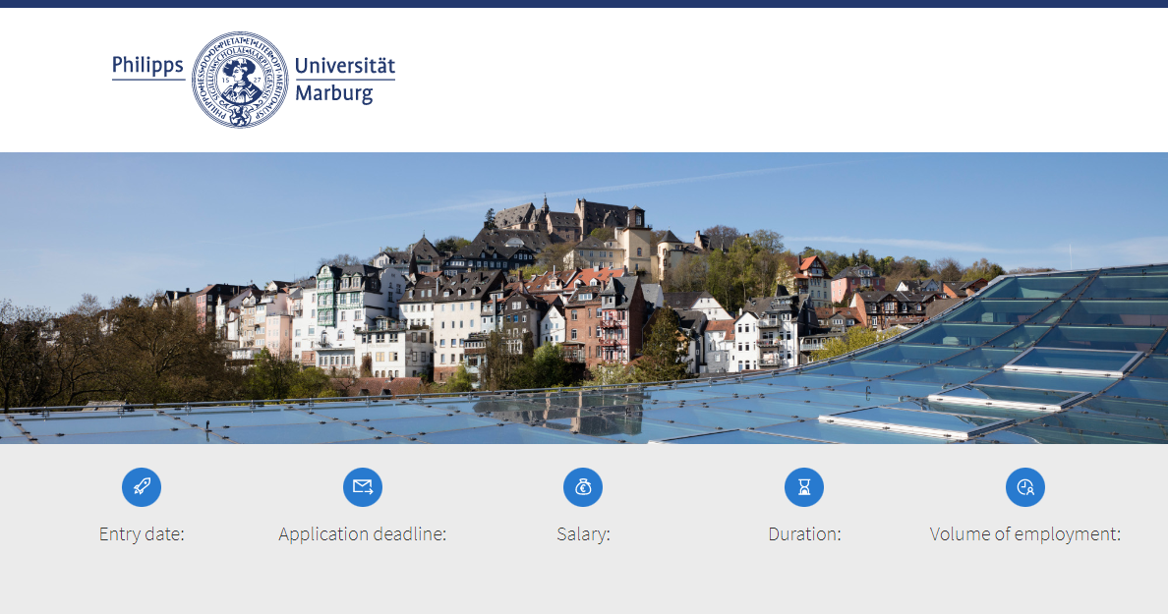
registration number: [wird von Dez II B 1 vergeben]

[as soon as possible or date] | [4 weeks] | [W1 Tenure Track to W2] | [X years] | [fulltime]
The Philipps University, founded in 1527, offers multiple award-winning teaching for around 22,000 students and tackles the important issues of our time with excellent research across a broad spectrum of science.

Text 1 (max. 600 signs; Explanations: one line are ca. 100 signs):
The Faculty of [Name][, Institute of…] invites applications for a

Title (max.l 200 signs):
Tenure Track Professorship (W1 Tenure Track to W2)
in [Denomination]

Text 2 (max. 1.000 signs):
The successful applicant is expected to strengthen the research priorities of the Faculty of [name] by establishing an in-dependent research group and to actively participate in research alliances and existing collaborative research initiatives of the Faculty of [Name] [such as ….] as well as in the overall research priorities of the University of Marburg.

Your tasks:

This call is explicitly aimed at researchers in the early stages of their scientific careers. The duration of the em-ployment in research and science after obtaining the doctoral degree should not exceed four years (in medicine: seven years in the case of successful completion of further medical training in accordance with Section 62 (6) Hess.HG). In addition, applicants should not have received their doctorate at the University of Marburg. In case the doctoral degree was ob-tained at the University of Marburg, the applicant should have worked in research and science outside of the University of Marburg for at least two years thereafter (in accordance with § 70 Abs. 3 Hessisches Hochschulgesetz Hess.HG, the State of Hessen Higher Education Act).

Your qualification:

We are looking for a highly qualified, internationally visible scientist with initial outstanding scientific achievements and an independent scientific profile [in the field of …] that demonstrates the potential for a further successful career in sci-ence at the highest international level. [Additional requirements, expectations].
The professorship is responsible for teaching ….

A completed university degree in [name] and an outstanding doctorate as well as a special pedagogical aptitude, are required. Experience in the successful acquisition of third-party funds will be considered an asset.
The employment requirements of §§ 67, 68 and especially 70 Hess.HG apply. The Tenure Track professorship is initially a grade W1 fixed term (6 years) position. If the requirements under general German civil service law are met, the applicant shall be granted a temporary civil service status for a period of six years. In the event of a positive evaluation of the pro-fessional, didactic and personal aptitude, the applicant will be granted a civil service status for life, combined with the assignment of a W2 permanent professorship. Further information on tenure track professorships at the University of Marburg is available at https://www.uni-marburg.de/de/universitaet/profil/Berufungskultur/tenure-track.

The University of Marburg attaches great importance to the intensive supervision of students and doctoral candidates and expects from its lecturers and thus from the applicants a distinctive presence at the university and a high degree of commitment in the field of academic teaching.

contact for more informations
[form of adress, title, name, surname]
 | [+49 6421-28 XXXXX] |  | [E-Mail]

We support women and therefore explicitly encourage them to apply. We welcome individuals with children - the Univer-sity of Marburg is committed to the goal of a family-friendly university. People with disabilities in the terms of the SGB IX (§ 2 Abs. 2, 3 SGB IX) are preferred if they are equally qualified for the position. Application and interview costs will not be reimbursed.

Please send your application documents (copies) including a research and teaching concept and the completed elec-tronic short questionnaire provided on https://uni-marburg.de/knGKf by [at least 4 weeks after publication] using the button below.

