„How to Study the Functional Materials M.Sc. Program according to the new examination regulations“
(Version from 2020)
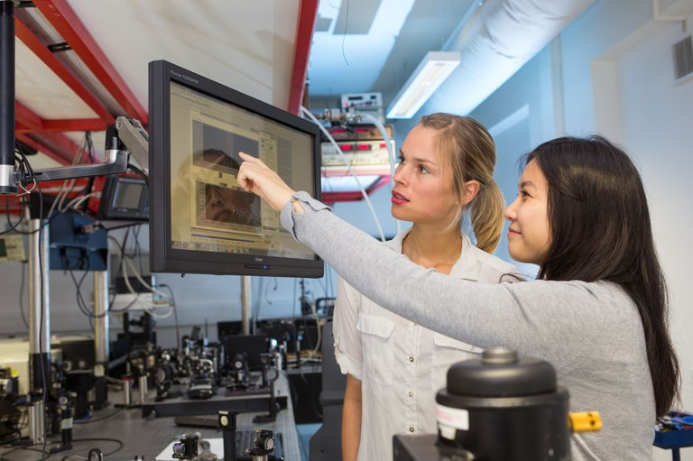
The purpose of this document is to provide you with helpful information on the structure and formal procedures within the Functional Materials M.Sc. Program (from now on referred to as “FM”).
Please note, however, that the legally binding document is the „Studienordnung“, which is available on the webpage of the Physics Department.
Semester Terms
There are two terms where the courses, etc. are given. These are the
Summer Term: April 1st – September 30rd
Winter Term: October 1st – March 31st
Both of these contain 6 months in total. However, only in a part of these the lectures take place (e.g. April 15th – July 15th and October 15th – February 15th). The “lecture-free time” in between these time frames should however not be misunderstood as “vacation time”, since sometimes examination will be placed in these weeks and some practical courses will also be conducted here. In particular the first two weeks after the nominal end of the lectures are often a time that is still important for your studies.
The relevant dates can always be found on the website of the university:
https://www.uni-marburg.de/studium/formalia/im_studium/termine (in German language only, “Vorlesungsbeginn” means “start of lectures”, “Vorlesungsende” means “end of lectures”).
Administrative Fees
Although attending a course program in Germany is generally free, you have to pay some money for the administrative work that is correlated with your studies here. At the moment, this amounts to about 300 €. It is necessary to transfer this money to the university at the correct time. If you have provided the university administration with your current address, you will receive a reminder for this payment. Furthermore, you can find all necessary information on the university website:
https://www.uni-marburg.de/studium/formalia/im_studium/rueckmeldung (in German language only, “Rückmeldefrist” means “time in which the fee has to be paid”).
Please note that the administrative fee also contains the costs for your ticket for the busses and trains within Marburg (& other cities in Hesse). Therefore, you can use all busses without having to pay for them. It is, however, necessary to always have your student ID as hand as well as personal ID with a photograph to allow your unambiguous identification.
Locations
Most of the courses that you will attend, will be held at the Renthof Campus. This is situated in the “old town” of Marburg. On the Renthof campus, there are four important buildings:
- Renthof 5: This is where most lectures are given, in particular in the “large lecture hall”, “the small lecture hall” and the “seminar room”. Furthermore, the research groups of Prof. Höfer and Prof. Jakob are located in this building.
- Renthof 6: In this building, some of the lab courses will be performed. Moreover, the research groups of Prof. Gebhard, Prof. Eckhardt and Prof. Noack have their offices here. In addition, the student examination office (Ms. Yvonne Michel) is located in this building.
- Renthof 7: Some lectures will be held here (mostly in the lecture room (basement) and the seminar room on the 3rd floor). The groups of Prof. Witte and Prof. Parak have their labs and offices here.
- Laborbau II: In this building, the research groups of Prof. Heimbrodt and Prof. Martin Koch (partially) have their labs and offices.
A map of the Renthof Campus is provided below:
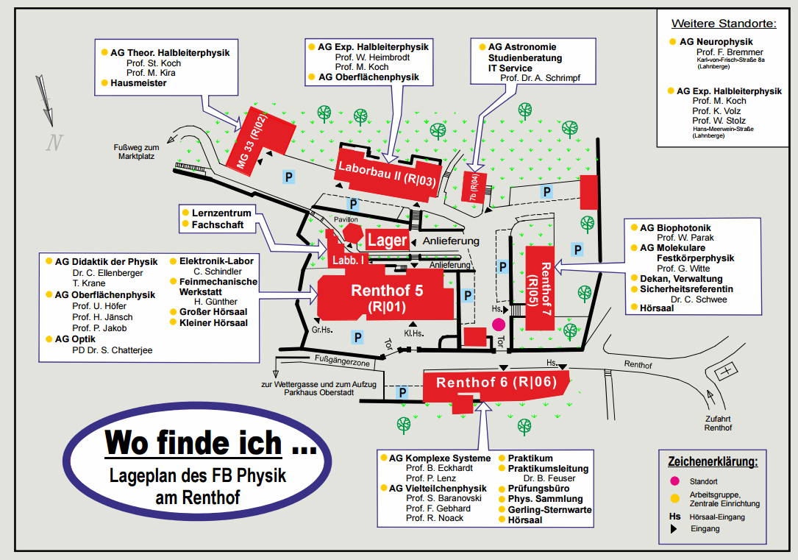

Some research groups are also placed on another campus, the Lahnberge campus. The entire chemistry department is placed there and also the groups of Prof. Volz, Prof. Stolz and Prof. Martin Koch (partially) have their labs and offices here. Therefore, some of the lab experiments will be performed at the Lahnberge campus. You can reach the Lahnberge campus easily via bus by using the line 7 and exiting at the station “Hans-Meerwein-Str.”. You then find the labs and offices of Prof. Volz’ and Prof. Stolz’ groups on level D2 in the “Mehrzweckgebäude” (see map below). The labs of Prof. Koch’s group are located at levels C3 and D3.

Structure of the Program
To finalize your studies in the FM, you have to obtain credit points in the following four sections:
- Fundamentals 48 Credits
- Electives 30 (36) Credits
- Profiles 12 (6) Credits
- Master’s Thesis 30 Credits
Either you complete 30 Credits in the elective area and 12 in the profile area or 36 Credits in the elective area and 6 in the profile area. A full list with all courses in a given semester is provided in the “Vorlesungsverzeichnis” (Course Catalogue), which you can find at https://marvin.uni-marburg.de/qisserver/pages/cm/exa/coursecatalog/showCourseCatalog.xhtml?_flowId=showCourseCatalog-flow&_flowExecutionKey=e1s1. Within this menu, you then have to select “Fachbereich Physik” and then “M. Sc. Functional Materials”.
Fundamentals
This section is formed by five courses, which are compulsive. Hence, all of these courses have to be attended and finalized by all students. The courses are:
- F1: Fundamentals of Functional Materials
- F2: Quantum Theory of Functional Materials
- F3: Basic Laboratory (see further details below)
- F4: Functional Materials Laboratory (see further details below)
- F5: Research Laboratory (see further details below)
Typically, F1 is offered in the winter term, F2 is offered in the summer term and F3 and F4 are available in both terms. The experiments at F3 take place in the lecture-free time after the semester.
In the old examination regulations there are similar modules, but these are marked with A1-A5. Make sure not to confuse these.
Basic Laboratory
The idea in the Basic Laboratory is that you will perform somewhat more complicated and larger experiments / series of experiments. This module is based on two pillars:
- “Light-Matter-Interaction”
This course takes place in the first two weeks after the lectures in the summer term (i.e. end of July / beginning of August). The experiments will take 2-3 days and you will again write a report about this.
- “Electronics Parcour”
This course takes place in the first two weeks after the lectures in the winter term (i.e. end of February / beginning of March). The experiments will take 2-3 days and you will again write a report about this.
For both parts, the report should be about 12 pages long. This module is not graded.
Please also note the information webpage for this module where the relevant information is found in more detail:
(So far the information about the Basic lab is not listed on that page (as of Nov. 11th, 2020). The info will be added there in details in the next weeks.)
https://www.uni-marburg.de/de/fb13/studium/praktika/praktika-fuer-physiker/lab-courses-in-the-m-sc-functional-materials
Functional Materials Laboratory
In this course, you will perform six experiments which are related to topics of the Functional Materials Program (out of a total number of ten). At this time, these experiments are:
- FML-1 Terahertz Spectroscopy
- FML-2 Luminescence and Absorption of Semiconductors
- FML-3 Scanning Probe Microscopy of Thin Molecular Films
- FML-4 Characterization of Solar Cells
- FML-5 X-ray Diffraction on Semiconductor Quantum Structures
- FML-6 Synthesis of Nanoparticles
- FML-7 Fluorescent Nanoparticles
- FML-8 Raman Spectroscopy
- FML-9 Semiconductor Laser Spectroscopy
- FML-10 Photoconductivity (currently not offered)
- FML-11 Functional Materials for Water Purification
- FML-12 Nanolithography
The experiments are typically performed on Monday (entire day). Sometimes, some additional hours are required on another day. Upon completion of the experiment, you will write a report for each experiment with a length of about 10-12 pages. In this, you will discuss the background of the experiment and in particular your own results. Details on the structure and contents of this protocol will be provided in the opening event for this course. This shall be handed to the experiment’s supervisor within 14 days after the experiment was performed. In many cases, the supervisor will ask for some additional re-corrections. You have to get certifications from the respective advisors that all your protocols are correct. At the end of the semester or at the beginning of the next one, there will be oral presentations, where you will perform a short PowerPoint presentation about one experiment that you have performed in which you will explain what was done in the experiment and what your main results were. This will be evaluated by a group of professors and will constitute your grade in this module.
Please also note the information webpage for this module where the relevant information is found in more detail:
https://www.uni-marburg.de/de/fb13/studium/praktika/praktika-fuer-physiker/lab-courses-in-the-m-sc-functional-materials
Research Laboratory
In this module, you will get the chance to perform a small research project on your own. This means that you will be provided with a research topic that is part of the expertise of one professor at the Physics department and you will work on that topic by yourself. (Of course you will get help, but unlike the other lab courses, there is no detailed manual and evaluation scheme here, but instead it is your responsibility to work out the details and make this “your own project”).
In many cases, the topic of your “Research Laboratory” will be in overlap with your future Master’s Thesis. Therefore, it is a good idea to reflect thoroughly what your interests are and which professor’s work you find appealing before making your choice. If you experience during your research lab that you want to perform your Master’s Thesis in another group, this is also possible (although not suggested).
You shall start your Research Laboratory only when you have successfully completed the main courses F1, F2, F3, and F4 and several electives (at least 3).
The research lab typically takes 14 weeks in which you are expected to work “full-time” (of course, selected days and hours can be taken off in compliance with the advisors). Upon finalization, you will give a short presentation (about 15 minutes) about your results to the group members with whom you have worked together. The presentation should contain a short motivation and introduction about what you did, your main experimental results, potential challenges during your lab as well as further plans and possible extensions of your work. This course is graded.
Master’s Thesis
The master’s thesis typically takes six months. To start your master’s thesis, it is required that you have already finished the functional materials laboratory (F4) and the research lab (F5) and have gathered at least 60 credits in total. Typically, you will perform the work for you master’s thesis in one of the workgroups at the department. Please note that some of the heads / professors of the workgroups have special expectations about the lectures that you have attended (e.g. lectures about their topic of research). Hence, it is suggested to contact the advisors which appear interesting to you sufficiently early to find out what knowledge they expect from you.
The Master’s Thesis module consists of the actual work to obtain the results (e.g. by working in the lab and analyzing the data) as well as the disputation, i.e. a presentation about the results. The workload for obtaining the results is defined as 24 credit points, for the presentation it is 6 points. Yet, due to the importance of an appropriate communication of your results, the actual calculation of your grade for this module is done such that obtaining the results is weighted as 20 points and the disputation is weighted as 10 points. This means, that the grade is calculated 2/3 by the work in the lab and 1/3 by the presentation (instead of 4/5 for the lab work and 1/5 for the presentation as you might expect considering the numbers from the workload estimations).

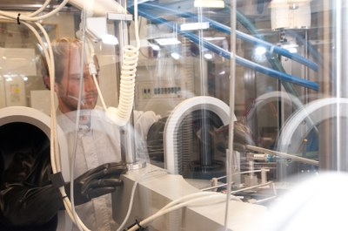
Electives
To gain the required 30 (36) credit points in the Electives section, you have to attend five (six) modules here. You are completely free to choose which ones you want to attend except you have to choose B13 or B17.
At the moment, the following elective courses are offered:
- B1: Methods in Materials Science 1
- B2: Methods in Materials Science 2
- B5: Molecular Materials 1
- B6: Molecular Materials 2
- B7: Solid State Spectroscopy 1
- B8: Solid State Spectroscopy 2
Please note: Modules “Solid State Spectroscopy 1 and 2” can be completed via courses “Laser Spectroscopy”, “Fundamentals of Semiconductor Physics” and/or “Semiconductor Physics and Devices”. These courses cannot be accounted for in other modules. Hence, taking all three of the aforementioned courses does not really make sense. (Of course you may participate if you are interested in all the contents, but you can only use two out of three to gather credit points. In any case, the grades of the first two completed courses will be counted, i.e. taking all three of them and then using the two best grades is not possible.).
- B9: Quantum Technology
- B10: Quantum Chemistry
- B11: Nanophysics and Nanotechnology (offered only every 2nd year)
- B12: Methods of Materials Characterization
- B16: Numerical Methods
- B13: Selected Topics in Functional Materials 1
- B17: Selected Topics in Functional Materials 2
- B18: Chemical Synthesis
- B19: Concepts of Functional Material 1
- B20: Concepts of Functional Material 2
- B21: Advanced Concepts of Functional Materials 1
- B22: Advances Concepts of Functional Materials 2
Typically, these are offered each second semester, i.e. once a year. Please note that some courses are split into two subcourses (e.g. Methods in Materials Science 1 & 2). It is probably the best approach to attend the 2nd course only after you have already completed the respective 1st part. If you believe that you can also start with the 2nd one, this is also possible.
All of these courses are graded. The grades will be defined either based on seminar talks which are provided by the students or a final oral or written examination. The details are provided in the respective module descriptions. (provided on https://www.uni-marburg.de/en/fb13/academics/degree-programs/msc-fm/masters-program/module-handbook) Please also make sure to look up the formal requirements for a participation in the respective courses (again in the aforementioned document or directly talk to the responsible professor).
Suggested Combinations for Electives
While you are generally free to choose from the available electives, some combinations appear particularly appropriate to develop an individual focus in Functional Materials. (as said before, you can of course combine differently if you wish!)
Such possible combinations are:
- Nanomaterials

- Molecular Materials 1
- Molecular Materials 2
- Quantum Technology
- Nanophysics and Nanotechnology
- Selected Topics in Functional Materials
Typical workgroups to join:
Molecular Solids (Prof. Witte), Surface Physics (Prof. Höfer, Prof. Jakob)

- Material Characterization and Growth

- Methods in Materials Science 1
- Methods in Materials Science 2
- Molecular Materials 1
- Methods of Materials Characterization
- Selected Topics in Functional Materials
Typical workgroups to join:
Structure and Techology Research Laboratory (Prof. Volz, Prof. Stolz)

- Spectroscopy of Functional Materials

- Methods in Materials Science 1
- Molecular Materials 1
- Solid State Spectroscopy 1/2
- Quantum Technology
- Selected Topics in Functional Materials
Typical workgroups to join:
Semiconductor Photonics (Prof. M. Koch), Molecular Solids (Prof. Witte)
- Profiles Section
As part of your studies in Functional Materials, you will also attend courses from other fields than the "core modules" in the so-called "Profiles module". In total, you will attend courses corresponding to 12 or 6 credit points.
You can use the courses listed in the course catalogue under
"Department 13 Physics" / "Masterstudiengänge" / "M. Sc. Functional Materials" / "Profiles"
to gather points for the "Profiles" section.
Generally, you may also attend other courses (from other departments than the Physics Department) than the ones listed there. In that case, however, it is neccessary to contact the examination office (Ms. Yvonne Michel) before the course starts in order to make sure that the course can actually be used. This is to make sure that you do not attend courses that cannot be registered / accounted for in the end.

Starting from winter term 2017/2018, we will offer a course in economics as a profiles module which is highly recommended for everybody. You find information on this course on
https://marvin.uni-marburg.de:443/qisserver/pages/startFlow.xhtml?_flowId=showEvent-flow&unitId=32256&termYear=2018&termTypeValueId=30&navigationPosition=studiesOffered,courseoverviewShow
You have to register for this course online!
Please note:
In the past, also language courses offered by the "Sprachenzentrum" could be used in the Profiles section. This is no longer possible. Hence, please consider this in the plan of your lectures.

IT Infrastructure
When registered as a student in Marburg, you are granted access to some IT infrastructure and services:
- E-Mail: As a student, you are provided with an email address from the university, typically of the kind yourname@students.uni-marburg.de . It is strongly advised that you use this address for all official communication with the professors and university staff. Some professors will not reply to your queries if you use an “unofficial” address (e.g. yahoo, Hotmail, gmail,…). Furthermore, it is necessary that you check your email folder of this address regularly to make sure that you receive all necessary information. Further information on how to use your mail account and how to setup your devices to synchronize with this, can be found at:

https://www.uni-marburg.de/hrz/internet/mail

- ILIAS System: In the ILIAS system, supporting information for the lectures is provided (e.g. copies of the slides, scripts for the lab courses, research papers, etc.). You can access the ILIAS system under the following address:
https:// lernen.uni-marburg.de

The login information is the same as for your email account.
- VPN Client: Some information is only accessible from the university network itself (e.g. from inside the university WIFI or when using a PC from the university). This is particularly important if you want to access data that is not freely available but where access is granted based on a university license (e.g. when using special software or downloading research papers). If you want to access these contents from home, you can log into the university virtual private network (VPN). For that purpose, you have to download a special tool (“VPN Client”) which allows you to work as if you were connected inside the university LAN. Further information and the required software can be found at
https://www.uni-marburg.de/hrz/internet/vpn/index_html-en?set_language=en

