Investigating the Potential of UV-excited Photoluminescence Spectroscopy for the Identification of Plastics
Gies S.¹, Schömann E.-M.¹, Radiev Y.¹, Prume J.¹, and Koch M.^{1*}
¹Department of Physics and Material Sciences Center, Philipps-University Marburg, Renthof 5, 35032 Marburg, Germany
*corresponding author: Prof. Dr. Martin Koch
e-mail: martin.koch@physik.uni-marburg.de

Abstract
In this study, we investigate photoluminescence (PL) spectroscopy with UV excitation as an alternative method for the detection and identification of plastic materials. The PL is excited at 266 nm. Spectra of the most widely used plastic materials are analyzed. Based on these results, it should be possible to develop a method to reliably identify different plastic materials in environmental samples solely based on their PL emission. In addition, this technique is inherently non-destructive and fast.
Keywords: Plastics, Photoluminescence, Microplastics
- Introduction
Nowadays, the increasing pollution of the environment with (micro-)plastics is an enormous problem. It was estimated that, in 2010 alone, between 5 and 12 million tons of plastics entered the oceans [Jambeck, 2015]. From there some plastic particles even made their way in the circulatory system of different marine organisms [Avio, 2017]. Clearly, a thorough risk assessment is necessary to determine the impact of plastics on the environment. To do so, it is important to identify and characterize the plastic materials, which is usually done using Raman spectroscopy or Fourier-transform infrared (FTIR) spectroscopy. Both methods have their advantages, but they also suffer from drawbacks such as long integration times (for Raman) or reduced efficiency if the particles are irregular and strongly scatter the light (FTIR) [Harrison, 2012].
Here, we study the potential of UV-excited PL to identify and characterize plastic materials. PL spectroscopy analyzes the light that is emitted by a sample after it was excited with photons. The emitted light is red-shifted with respect to the excitation because of internal conversion processes. Therefore, the PL spectra contain valuable information about the material, which can be used to identify it. Though PL is used in many areas such as materials sciences, biology and medicine [White, 1970], only few studies on the application to plastics exist.
- Experimental Methods
To reveal the spectroscopic fingerprint of different plastic materials, we chose to investigate commercially available, macroscopic pieces. We have refrained from investigating PL spectra of natural materials commonly found in the environment. Ornik et al. have already shown the distinctness of their spectra [Ornik, 2019]. The samples were (5x5) cm² with a thickness of 3 mm and were bought from Technoplast GmbH. We have investigated three kinds of poly(ethylene) (HD-PE, PE1000, PE500), Poly(ethyl benzene-1,4-dicarboxylate) (PET), Poly(oxymethylene) glycol (POM-C), Poly(1-phenylethene) (PS), poly(hexan0-6-lactam) (PA6), poly[imino(1,6-ioxohexamethylene)iminohexamethylene] (PA6,6), the poly(carbonate) (PC) Makrolon, poly(methyl-2-methylpropenoate) (PMMA), poly(propene) (PP), poly(tetrafluoroethylene) (PTFE), and poly(1-chloroethylene) (PVC). The PL was measured using a standard setup consisting of a TOPTICA TopWave266 frequency-quadrupled cw-Nd:YAG laser operating at 266 nm. The second harmonic at 532 nm was removed from the excitation light using a prism. The samples were excited at an excitation density of approximately 40 W/cm². The emitted PL was collected using UV-transparent lenses. The spectra were recorded using a OceanOptics HR4000 spectrometer, which is sensitive from 196 nm to 1102 nm. A 280 nm edge filter was placed in front of the spectrometer to prevent radiation damage. The measurements were performed at room temperature and the acquisition time was 1 second.
- Results and Discussion
The PL spectra of the investigated materials are shown in Figure 1. The spectra were normalized to their respective maximum. For all samples the PL emission can be observed very well. Different features can be observed in the spectra. For HDPE, PE1000, POMC and PE500 a strong peak in the range of 300 nm can be observed. This peak has several shoulders in this wavelength range for these samples. Additionally, there is a second emission maximum around 500 nm. PA6 behaves differently showing one very broad emission from approximately 320 nm to 550 nm. All other investigated materials have a dominant peak at roughly 500 nm, which is asymmetrically broadened and has a more or less pronounced shoulder on the high-energy side. 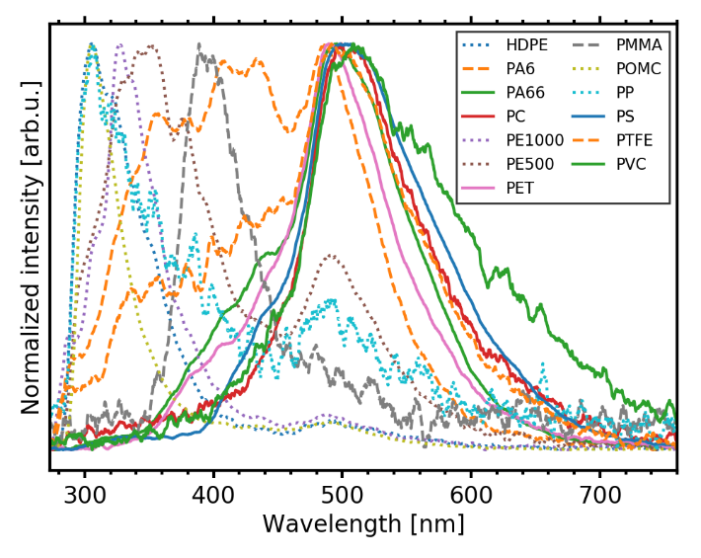
Figure 1: PL spectra of the investigated plastic samples. The spectra are normalized to unity.
To further analyze and compare the spectra, we use the following method. The integrated intensity of the PL in a 50 nm-wide window around the center-wavelengths of 325 nm, 400 nm and 500 nm is determined and denoted I₃₂₅, I₄₀₀ and I₅₀₀, respectively. Then, the parameters P₁ and P₂ are defined as:${ P}_{1}=\frac{I_{325}}{I_{400}} and P_{2}=\frac{I_{500}}{I_{400}}$ . The spectra can then be analyzed by plotting the P₂ value as a function of P₁ (see Figure 2). Normalizing the spectra, as done in Figure 1, does not influence the results of this technique as both parameters scale in the same way by scaling the full spectrum with a factor. Therefore, intensity differences between the samples, which are difficult to measure in an absolute manner in PL, do not interfere with the results. It can be seen in Figure 2, that all materials can easily be distinguished from another. Only for PC and PVC the data points are close together. If the emission is predominantly in the short-wavelength region (in the long-wavelength region), the materials have higher values of P₁ (P₂). Materials with their main emission in the intermediate wavelength range around 400 nm, such as PMMA, appear close to P₁ ≈ P₂ ≈ 0. PA6 with its uniquely brosd emission is located at P₁ ≈ P₂ ≈ 1. It is interesting to note that the PE-type materials and PP all have values of P₁ > 2 and P₂ < 2, which might be because they are chemically alike. POM-C also falls in this group. The materials having P₂ > 2 and P₁ ≈ 0 are chemically rather different from PE or PP but also within themselves. Therefore, the exact reason for this grouping needs to be investigated further. Nevertheless, it is possible to distinguish the different materials solely by using their spectra.
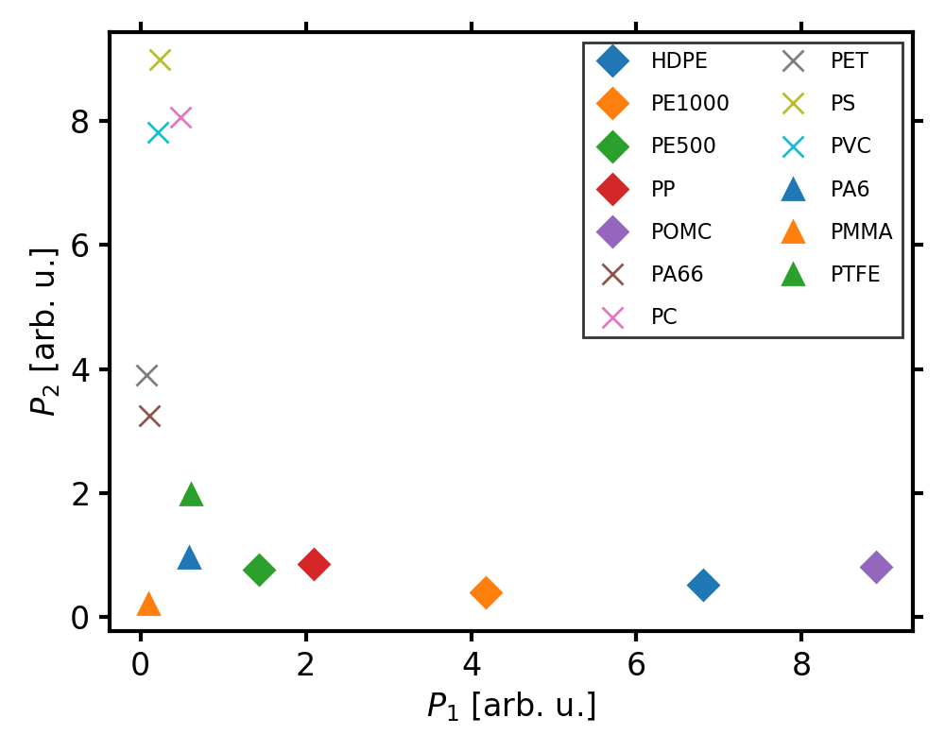
Figure 2: Plot of the intensity parameters P₁ and P₂.
- Conclusions
For the first time, a comprehensive analysis of the UV-excited PL of plastic materials is given. The PL spectra of all investigated materials could be observed very well. Using the ratios of the luminescence intensity at selected wavelengths, it was possible to distinguish between all investigated materials. Yet, for higher excitation powers, radiation damage was observed. This necessitates future studies to reveal the influence of UV-ageing on the spectra. In the future, more materials should be investigated. Additionally, samples from the environment must be analyzed to account for radiation damage, the influence of salt water, encrustation with biological material and other such factors.
However, the results presented here indicate that UV-excited PL is a promising technique for the identification of plastic materials.

Acknowledgements
The authors gratefully acknowledge TOPTICA Photonics AG for providing the TopWave266 laser.

References

Jambeck J.R., Geyer R., Wilcox C., Siegler T.R., Perryman M., Andrady A., Ramani N., and Law K.L. (2015), Plastic Waste inputs from land into the ocean, Science, 347, 768-771.
Avio, C.G., Gorbi S. and Regoli F. (2017), Plastics and microplastics in the oceans: From emerging pollutants to emerged threat, Marine Environmental Research, 128, 2-11.
Harrison J.P., Ojeda J.J., Romero-González M.E. (2012), The applicability of reflectance micro-Fourier-transform infrared spectroscopy for the detection of synthetic microplastics in marine sediments, The science of the total environment, 416, 455-463.
White C.E. and Argauer R.J. (1970), Fluorescence Analysis A Practical Approach, Marcel Dekker, New York.
Ornik J., Sommer S., Gies S., Weber M., Lott C., Balzer J.C., and Koch M. (2019), Could photoluminescence spectroscopy be an alternative technique for the detection of microplastics? First experiments, submitted.

